1. **Install oracle datamodeler on Linux Ubuntu**

<https://snapcraft.io/osddm>

1. **Scroll Speed Mouse Ubuntu**

*You have to install imwhell with :*

*sudo apt install imwheel*

*And download this bash script on* [*http://www.nicknorton.net*](http://www.nicknorton.net) *(thanks to him)*

*You can type, as @victoor say in comments :*

*You can just do* bash <(curl -s http://www.nicknorton.net/mousewheel.sh) instead of copy the script manually and changing permissions. :)

*bash <(curl -s* [*http://www.nicknorton.net/mousewheel.sh*](http://www.nicknorton.net/mousewheel.sh)*)*

1. **Cek Suhu Linux**

[***https://www.linuxsec.org/2019/05/cara-memeriksa-temperatur-cpu.html***](https://www.linuxsec.org/2019/05/cara-memeriksa-temperatur-cpu.html)

1. ***Install Gtkstresstesting Linux***

[***https://linuxhint.com/install-use-gtkstresstesting-app-linux/***](https://linuxhint.com/install-use-gtkstresstesting-app-linux/)

1. ***problem entering password github push repository***

[***https://www.theserverside.com/blog/Coffee-Talk-Java-News-Stories-and-Opinions/Fix-GitHubs-support-for-password-authentication-was-removed-error***](https://www.theserverside.com/blog/Coffee-Talk-Java-News-Stories-and-Opinions/Fix-GitHubs-support-for-password-authentication-was-removed-error)

1. ***install driver rtl8821ce-dkms***

[***https://medium.com/@kimiyukiyukawa/installing-rtl8821ce-network-controller-on-ubuntu-335d8ccb8a92***](https://medium.com/@kimiyukiyukawa/installing-rtl8821ce-network-controller-on-ubuntu-335d8ccb8a92)

1. ***ppa driver wifi ubuntu***

[***https://launchpad.net/~kelebek333/+archive/ubuntu/kablosuz***](https://launchpad.net/~kelebek333/+archive/ubuntu/kablosuz)

1. ***update vscode***

[***https://askubuntu.com/questions/833448/how-can-i-update-visual-studio-code-on-ubuntu***](https://askubuntu.com/questions/833448/how-can-i-update-visual-studio-code-on-ubuntu)

*sudo apt update*

*sudo apt install code*

1. ***lsb module install***

[***https://askubuntu.com/questions/230766/how-lsb-module-affects-system-and-can-be-made-available-to-the-system***](https://askubuntu.com/questions/230766/how-lsb-module-affects-system-and-can-be-made-available-to-the-system)

1. ***cek hardware pc linux***

*glxinfo -B*

1. ***dpkg: error processing package install-info (--configure): installed install-info package post-installation script subprocess returned error exit status 2***

[***https://askubuntu.com/questions/1069702/dpkg-error-processing-package-install-info***](https://askubuntu.com/questions/1069702/dpkg-error-processing-package-install-info)

*sudo mv /var/lib/dpkg/info/install-info.postinst /var/lib/dpkg/info/install-info.postinst.bad*

1. ***org.postgresql.util.PSQLException: FATAL: password authentication failed for user "postgres"***

*sudo systemctl restart postgresql*

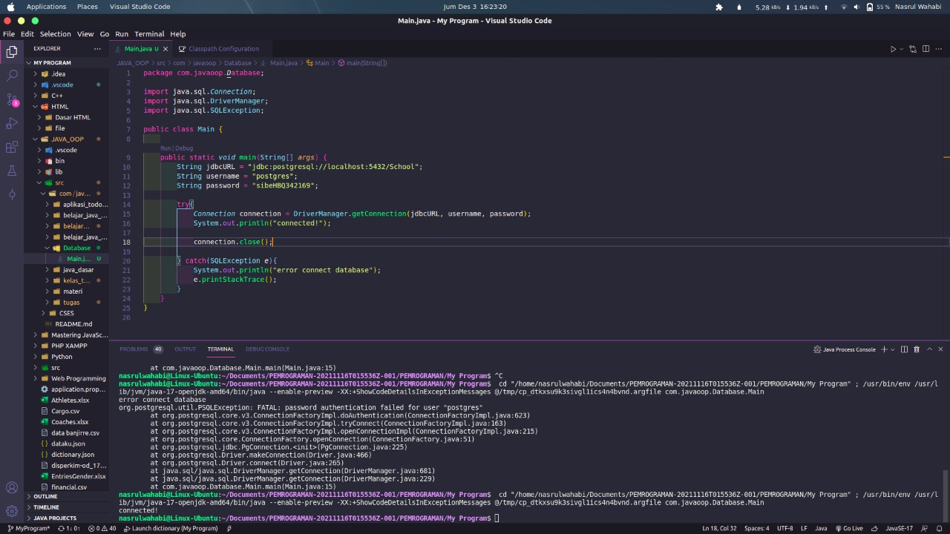[***https://stackoverflow.com/questions/38427407/caused-by-org-postgresql-util-psqlexception-fatal-password-authentication-fai***](https://stackoverflow.com/questions/38427407/caused-by-org-postgresql-util-psqlexception-fatal-password-authentication-fai)

1. ***The import org.apache.commons.lang3 cannot be resolved***

[***https://stackoverflow.com/questions/22805854/the-import-org-apache-commons-lang3-cannot-be-resolved?rq=1***](https://stackoverflow.com/questions/22805854/the-import-org-apache-commons-lang3-cannot-be-resolved?rq=1)

1. ***Install PgAdmin4***

[***https://tecadmin.net/how-to-install-pgadmin4-on-ubuntu-20-04/***](https://tecadmin.net/how-to-install-pgadmin4-on-ubuntu-20-04/)

1. ***Install pygame Ubuntu***

[***https://askubuntu.com/questions/399824/how-to-install-pygame***](https://askubuntu.com/questions/399824/how-to-install-pygame)

1. ***Install xdm Ubuntu***

[***https://itsfoss.com/xtreme-download-manager-install/***](https://itsfoss.com/xtreme-download-manager-install/)

1. ***Ss di Linux***

[***https://id.wikihow.com/Mengambil-Tangkapan-Layar-di-Linux***](https://id.wikihow.com/Mengambil-Tangkapan-Layar-di-Linux)

1. ***Uninstall Java Linux***

[***https://lebakcyber.net/cara-uninstall-jdk-di-linux-ubuntu/***](https://lebakcyber.net/cara-uninstall-jdk-di-linux-ubuntu/)

1. ***Shutdown & Restart Ubuntu***

*sudo shutdown now*

*sudo reboot*